**ROUND 2:**

1. B. 1894

Bonus: 1999

2. U.S Highway 20 from Boston, MA to Newport, OR

3. A. Homestead Florida, The City of Bicycles

4. D. Fort Missoula, MT to St. Louis, MO

5. Annie “Londonderry” Kopchovsky

Note: Either of the above last names is acceptable

6. Lausanne, Switzerland

7. B. Grants Pass, OR

8. Emmen, Netherlands

**TOTAL SCORE:** 11 possible points

**ROUND 1:**

1. C. 1889

2. Boris Johnson, former mayor of London

3. D. Over 71,000,000

4. The Yellow Bike Program

5. B. China

6. Draisienne, draisine, velocipede, dandy horse

7. B. 1974

8. C. Davis, CA in 1967

**TOTAL SCORE:**  10 possible points

**TEAM NAME: Answer Key and the Know It Alls** – seriously though, this is the answer key.

The Community Cycling Center’s **mission** is to broaden access to bicycling and its benefits.

Our **vision** is to build a vibrant community where people of all backgrounds use bicycles to stay healthy and connected.

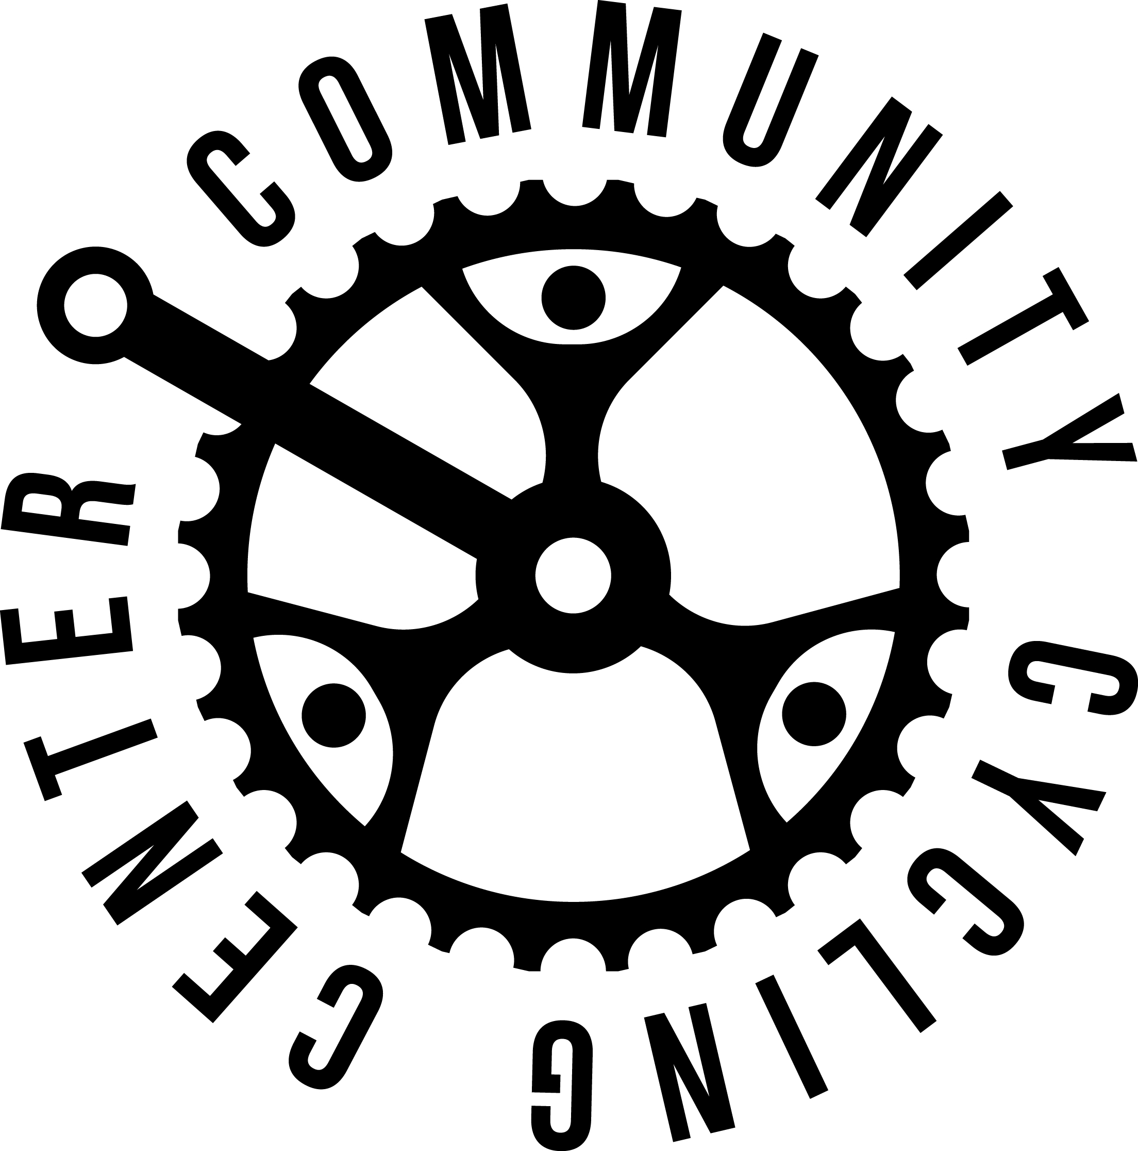

**ROUND 3:**

1. A. Oklahoma City in 1935

2. Seoul

3. C. 693

4. Tactical Urbanism

5. Bikecentennial

6. Groeningen

7. Tacoma Narrows Bridge

Bonus: Galloping Gertie

8. 2012

**TOTAL SCORE:** 11 points possible

Thank you for playing Transportation Trivia! 100% of your entry fee &

10% of the proceeds at the bar support the Community Cycling Center tonight.

We appreciate your support!

**FINAL SCORE:** 32 points possible